**Final Report**

|  |  |
| --- | --- |
| Group # | CP 5 |
| Student Name | Rakesh Mahendranath, Govind Kala Raveendran, Charumathi Satish, Aiswarya Raj, Het Chandubhai Patel, Vignesh Ramasubramanian |
| Course | INFO8686 – Information Technology Business Analysis Capstone Project |
| Section | 5 |
| Professor | Prof. Nilesh Deshmukh |
| Due Date | April 11th, 2024 |

Catalyst Driving Business Excellence

Kitchener, Ontario

Generative AI Powered Voice Assistant Customer Service at Rogers

Contents

Overview of Company 3

Core Divisions 4

Additional Divisions 4

Financial Status 4

Revenue Analysis 5

Market Share 6

Executive Team 6

Mission and Vision 10

Action Items & Goals 10

Executive Summary 10

Team Members and Responsibilities 11

Business Requirements 11

As- Is – Flow 13

Main – Process 14

Sub–Process 15

RACI Matrix 16

17

Solution Requirements 17

Functional Requirements 18

Non-Functional Requirements 19

Feasibility Analysis of Proposed Solutions 19

POSSIBLE SOLUTION #1 – (Outsourcing AI Customer Service Call Platform) 20

High-Level Design 20

Impact Analysis 21

Out of Scope 22

Risk and Mitigation 22

POSSIBLE SOLUTION #2 – (Using Third-party AI products) 23

High-Level Design 24

Impact Analysis 24

Out of Scope 25

Risk and Mitigation 25

POSSIBLE SOLUTION #3: Do Nothing Method 26

Impact Analysis 26

Risks and Mitigation 27

Evaluation Criteria 28

People 28

Process 29

Technology 31

Database Design 33

Tables 35

Primary Keys 39

Dependencies of data elements 40

Solution Recommendation 41

ROI Comparison of Customer Service Solutions 42

Implementation Strategy 43

Testing Strategy 45

Defect Flow 47

Test Environment 48

Testing Tools 48

Test Sign off: 48

Risk Management 48

# Overview of Company

Rogers Communications Inc., headquartered in Toronto, Ontario, is a leading Canadian company specializing in wireless communications, cable television, telephony, and internet services. With a rich portfolio of telecommunications and mass media holdings, Rogers operates across multiple divisions to serve diverse customer needs.

## Core Divisions

* **Rogers Wireless:** A pioneer in wireless communication services, offering mobile voice, data, and messaging solutions. Rogers boasts the largest 5G network in Canada, serving over 1,900 locations as of December 31,2022.
* **Rogers Cable:** Providing cable television, high-speed internet, home phone services, smart home monitoring, and advanced home Wi-Fi services primarily in Ontario, New Brunswick, Nova Scotia, and Newfoundland.
* **Rogers Sports & Media:** Focused on sports content and media ventures, including ownership of the Toronto Blue Jays and broadcasting partnerships with the NHL, delivering over 1,300 regular season games per season.

## Additional Divisions

* **Rogers Communications:** Offering television, radio, digital media, and publishing assets to provide entertainment and information services.
* **Rogers Smart Home Monitoring**: Providing comprehensive connected home solutions for residential and business customers.
* **Rogers for Business:** Catering to the communication and technology needs of businesses.
* **Rogers Bank:** Managing financial products and services, including Rogers Bank.

## Financial Status

Rogers Wireless serves approximately 10.6 million mobile phone subscribers and holds a 30% subscriber and revenue share of the Canadian wireless market.

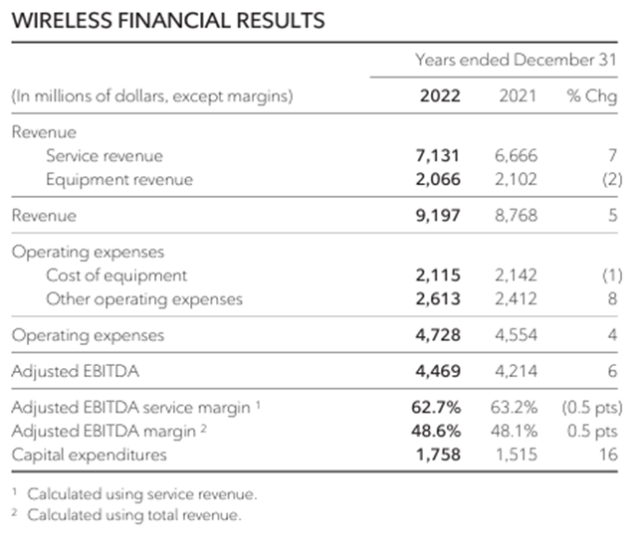

Rogers Cable has around 2.3 million retail internet subscribers and 1.5 million video subscribers, with a network passing of 4.8 million homes.

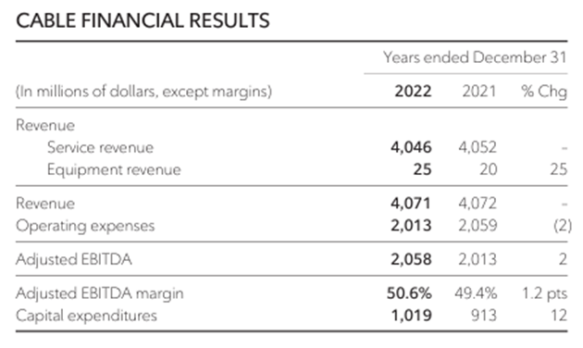

Rogers Sports & Media encompasses a $2 billion business with approximately 3,000 employees, owning sports teams and broadcasting partnerships.

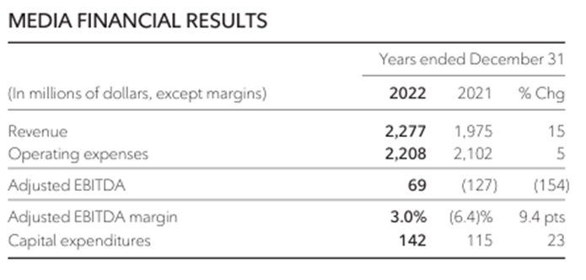

## Revenue Analysis

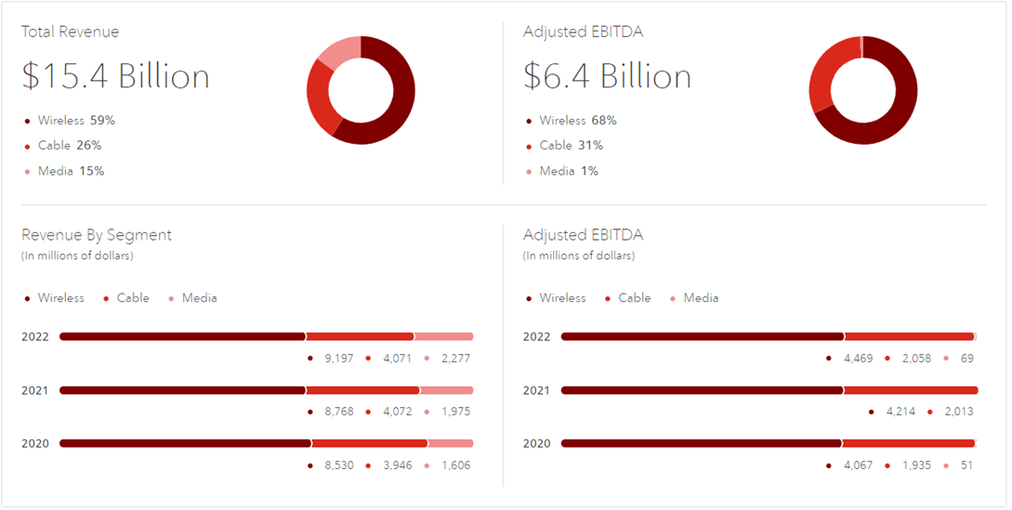

## Market Share

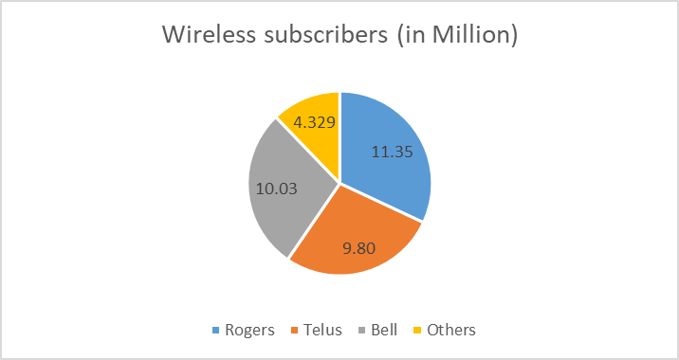

## Executive Team

The leadership team at Rogers, including President and CEO Tony Staffieri and executives like Phil Hartling, Colette Watson, and Robert Depatie, brings extensive experience in telecommunications and media, driving innovation and growth across the organization.

|  |  |  |
| --- | --- | --- |
| **Name** | **Position** | **Description** |
| **Tony Staffieri** | President and CEO | Tony Staffieri, President, and CEO of Rogers Communications, is a seasoned leader with a nine-year tenure as Chief Financial Officer, driving strong results and shareholder value. His diverse leadership background includes roles at Price Waterhouse Coopers, Celestica International, and Bell Canada Enterprises. Beyond his corporate role, Tony is actively involved as Chair of the Toronto Metropolitan University Board of Governors and a Board Director at Maple Leaf Sports & Entertainment (MLSE). |
| **Phil Hartling** | President, Wireless | Phil Hartling, as President, of Wireless at Rogers, oversees the company's Wireless business encompassing the Rogers, Fido, and Chatr brands. With over 30 years of telecom experience, Phil has held various leadership roles, demonstrating a strong track record of profitable growth, operational discipline, and team building. Notably, he led the service area expansion program and previously headed the Connected Home business at Rogers. |
| **Colette Watson** | President, Rogers Sports & Media | As the President of Rogers Sports & Media since January 2022, Colette Watson leads a $2 billion business with around 3,000 employees, overseeing diverse sports and media properties, including TV channels, radio stations, OTT services, podcast networks, and more. With 30 years of experience in Canada's broadcast industry, Colette has held senior roles in programming, regulatory affairs, and communications at Rogers Media. Beyond her corporate responsibilities, she is passionate about public affairs and journalism, having served as the President of CPAC. |
| **Robert Depatie** | President & COO, Home & Business Division at Rogers Communications | Robert Depatie, President and COO of Rogers' Home and Business Division, brings nearly 20 years of telecom and media leadership. Formerly CEO of Quebecor and President of Videotron, he emphasizes customer-first strategies, driving notable improvements in satisfaction and business growth. Committed to the community, he engages in fundraising and initiatives for rehabilitation and community development. |
| **Ron McKenzie** | Chief Technology and Information Officer | As Chief Technology & Information Officer at Rogers Communications since July 2022, Ron McKenzie leads a team overseeing wireline, wireless, and media networks, along with IT and digital strategy. With over 30 years in the technology and telecom industry, he previously served as President, of Rogers for Business, focusing on delivering solutions to businesses. Ron's leadership includes successful transformations in Technical Operations during the COVID-19 pandemic, ensuring customer connectivity and team safety. |
| **Glenn Brandt** | Chief Financial Officer | As the Chief Financial Officer of Rogers Communications since January 2022, Glenn Brandt brings over 35 years of financial management expertise, specializing in corporate finance, capital raising, and credit rating agencies. With a 31-year tenure at Rogers, he previously served as Senior Vice President of Corporate Finance, overseeing Procurement, Supply Chain, Tax, Treasury, and pension investing. Glenn's extensive background includes leadership in the Treasury, contributing to approximately $50 billion in public debt issues for Rogers in Canada and the United States. |
| **Mahes Wickramasinghe** | Chief Commercial Officer | As Chief Commercial Officer at Rogers since January 2022, Mahes Wickramasinghe oversees key initiatives and operations, including Strategy, Corporate Development, and Financial Services, including Rogers Bank. With over two decades of senior executive experience, he previously led Canadian Tire Financial Services and held roles at Canadian Tire Corporation, CIBC Retail Bank, Bell Aliant, BCE Inc., and Rogers Communications. Mahes, a Chartered Accountant, is actively involved in various boards, including SunOpta Inc. and The Association of International Certified Professional Accountants. |
| **Marisa Wyse** | Chief Legal Officer and Corporate Secretary | As Chief Legal Officer and Corporate Secretary at Rogers, Marisa Wyse is a strategic leader with expertise in legal and regulatory affairs. Joining Rogers in 2014, she has played key roles in Tax and Finance and served as Vice President of Corporate Development, overseeing mergers and acquisitions. |
| **Bret Leech** | Chief Human Resources Officer | Bret Leech, the Chief Human Resources Officer at Rogers since February 2022, leads the company's HR portfolio, focusing on creating an engaging and inclusive employee experience. With 25 years of international leadership experience in telecommunications, finance, and technology, Bret has a strong track record in building high-performing teams. |
| **Terrie Tweddle** | Chief Brand and Communications Officer | As the Chief Brand and Communications Officer since April 2023, Terrie Tweddle leads communications and brand efforts at Rogers, focusing on enhancing the company's reputation. With 25 years of experience, she has a passion for building culture, managing complex issues, and creating award-winning campaigns. Notably, she returned to Rogers in 2022 after a 12-year tenure at the company, showcasing her commitment to its continued success. |
| **Navdeep Bains** | Chief Corporate Affairs Officer | As Chief Corporate Affairs Officer at Rogers since May 15, 2023, The Honourable Navdeep Bains leads Public Policy and Environmental, Social, and Governance (ESG) efforts, leveraging his expertise to address critical issues in Canada's digital economy. Formerly Vice-Chair in Global Investment Banking for CIBC, he played a key role in strengthening Capital Markets and Commercial Banking with a focus on Innovation and Sustainability. With a distinguished background, Navdeep served as one of the longest-serving federal Ministers of Innovation, Science, and Industry, introducing a comprehensive innovation and skills plan for Canada. |
| **Zoran Stakic** | President, Residential | As President of residential at Rogers since September 2023, Zoran Stakic oversees strategy and operations, bringing 25 years of deep telecom sector experience. Formerly Chief Transformation Officer, he led the integration process of Shaw and Rogers, ensuring a seamless transition. Zoran's extensive executive leadership background includes roles at Shaw, where he served as Chief Operations Officer and Chief Technology Officer. |

## Mission and Vision

Rogers' mission is to connect Canadians responsibly, prioritizing continuous learning, corporate social responsibility, and environmental sustainability. Their vision is to lead in corporate social responsibility, setting new standards for excellence and innovation, while contributing to positive change and fostering a sustainable future.

## Action Items & Goals

Rogers aims to differentiate itself through superior customer service, explore options to enter the US market, leverage acquisitions like Shaw Communications Inc., and promote programs like Connected to Success to attract new customers.

# Executive Summary

Rogers Communications Inc. faces significant challenges in its traditional customer service model, characterized by long call queues and communication deficiencies, resulting in high customer complaints and resource waste. The company's commitment to improving customer experience and operational efficiency has led to the development of the AI Customer Service Call Platform project.

The AI platform aims to revolutionize customer service by intelligently handling complaints, reducing wait times, and optimizing resources. Leveraging Natural Language Processing (NLP) and predictive analytics, the system will accurately understand and address customer queries while forecasting and preventing recurring issues.

Key features include intelligent call handling, efficient call routing, NLP capabilities, seamless integration with existing systems, scalability, flexibility, and personalization. By meeting these requirements, the platform aims to achieve efficient service delivery, precise query resolution, and natural, intuitive interactions, ultimately enhancing overall customer engagement.

The project will deliver various management and product-related deliverables, including project management documents and product specifications. With Rogers' extensive portfolio spanning wireless, cable, and media divisions, the AI Customer Service Call Platform aligns with the company's mission to connect Canadians responsibly and innovatively.

The project presents an opportunity for Rogers to differentiate itself from competitors, improve market share, and address external threats such as changing consumer preferences and regulatory challenges. By prioritizing customer service excellence and embracing innovative solutions, Rogers aims to solidify its position as a leader in the telecommunications industry while delivering on its vision of responsible corporate citizenship and sustainable innovation.

# Team Members and Responsibilities

|  |  |  |  |
| --- | --- | --- | --- |
| ***Name and Signature*** | ***Role*** | ***Organization*** | ***Contact Information*** |
| Nilesh Deshmukh | Sponsor | Rogers | +1(519)-819-xxxx |
| Aiswarya Raj | Project Manager | Catalyst | +1(226)-579-xxxx |
| Rakesh Mahendranath | Assistant Project Manager | Catalyst | +1(519)-156-xxxx |
| Govind Kala Raveendran | Business Analyst | Catalyst | +1(456)-720-xxxx |
| Charumathi Satish | Business Analyst | Catalyst | +1(411)-861-xxxx |
| Vignesh Ramasubramanian | Business Analyst | Catalyst | +(519)-765-xxxx |
| Het Chandubhai Patel | Business Analyst | Catalyst | +(226)-581-xxxx |

# Business Requirements

1. Customer Service Context Handling: The AI assistant must adeptly handle various customer service contexts, including billing inquiries, device issues, order tracking, etc.
2. Integration with Existing Systems: AI conversations should seamlessly integrate with existing systems such as CRM to access relevant customer data.
3. Utilization of AI/ML in Customer Service: Determine if Rogers currently employs AI/ML in customer service and share related documentation if available.
4. Customer Service KPIs Tracking: Track KPIs like call wait times, resolution times, and rates to monitor and enhance customer service effectiveness.
5. Handover Mechanism for Complex Issues: Document Rogers' current handover mechanism for complex customer issues within the customer service context.
6. Alignment with Architectural Principles: Ensure AI solutions align with Rogers' architectural principles, including data security and vendor standards.
7. Service Level Agreements (SLAs): Define SLAs for different customer issue types based on priority to ensure timely resolution.
8. Privacy and Security Standards: Ensure the AI voice assistant meets essential privacy and security standards to safeguard customer data.
9. Language Support: Support multiple dialects and languages to cater to Rogers' diverse customer base.
10. Consistent and Accurate Responses: Implement methods to ensure AI voice assistance consistently and accurately answers consumer inquiries.
11. Personalization and Customization: Define the degree of personalization and customization expected in the AI voice assistant system.
12. User Load and Scalability Requirements: Specify expected user load and scalability requirements for the platform to accommodate business growth.
13. NLP Performance Enhancement: Recommend approaches to enhance NLP performance in understanding customer complaints.
14. Brand Alignment: Implement measures to ensure AI platform interactions align with Rogers' values, protecting brand image and reputation.
15. Implementation and Deployment Approach: Recommend an approach for implementing and deploying the AI platform effectively.
16. Backup and Maintenance Measures: Define measures for regular backups, restores, and maintenance of the AI platform.
17. Access Control and Authentication: Implement robust access control mechanisms and authentication protocols within the AI platform.
18. Proactive Maintenance Alerts: Define how the AI platform should proactively generate maintenance alerts and notifications based on predictive analytics.
19. Performance Expectations: Define performance expectations in terms of response times and throughput for the AI system.
20. User Experience Enhancement: Employ strategies to ensure intuitive navigation and seamless user experience within the AI platform for internal customers.

# As- Is – Flow

## Main – Process

1. The process begins with a customer calling Rogers.
2. The recorded voice prompts the customer to Press 1 for English or Press 2 for French.
3. Voice then asks the customer to input their account number. A condition is checked to determine whether the account number has been identified.
4. If the account number is identified, the customer is presented with the following options:

* Press 1 for Billing & Payment
* Press 2 for Technical Support
* Press 3 for Add Product and Services
* Press 4 for Account Change
* Press 5 to Talk to a Customer Agent.

1. If the customer selected option 5, the call is transferred to a live customer agent. The agent receives the call and resolves the customer's issue.
2. After resolving the issue, a condition is checked to determine if the customer is satisfied.
3. If the customer is satisfied, the process stops. If the customer is not satisfied, a ticket is created and transferred to the resolution department.
4. The ticket is escalated to the resolution department. The resolution department works to solve the issue. Once the issue is resolved, the process stops.
5. If the customer did not select option 5, the process enters a sub-process named *‘Options Resolution Process.’*
6. The sub-process presents various options to the customer based on their needs.
7. After the sub-process, a condition is checked to determine if the issue is solved. If the issue is solved, the process stops. If the issue is not solved, a ticket is created and transferred to the resolution department.
8. The ticket from the sub-process is escalated to the resolution department.
9. The resolution department works to solve the issue. Once the issue is resolved, the process stops.

## Sub–Process

**1.** If the condition is true (Option Selected = 1), the sub-process presents the following options:

* Press 1 for Plan Related Issue
* Press 2 for Account Related Issues
* Press 3 for Issue in Billing

1. If the customer selects 3 for ***the Issue of Billing***, the process addresses billing-related problems.
2. After resolving the billing issue, the System will check if the issue is resolved or not.
3. If yes, the process Stops.
4. If not, a ticket is created and transferred to the resolution department. After the issue is solved, the process stops.

**2.** If the initial condition (Option Selected = 1) is false, it enters another condition to check if Option Selected = 2.

a) If the condition is true, the process directs the customer to talk to the virtual assistant for assistance.

After interacting with the virtual assistant, the system will check if the issue is resolved or not.

If yes, the process stops.

If not, a ticket is created and transferred to the resolution department. After the issue is solved, the process stops.

**3.** If the previous condition (Option Selected = 2) is false, it enters another condition to check if Option Selected = 3.

a)If the condition is true, the process presents the following options:

* Press 1 for Mobile
* Press 2 for Residential and home Internet.

b) Depending on the customer's selection, the process addresses issues related to mobile or residential/home internet.

c) After resolving the specific issue, the system will check if the issue is resolved or not. If yes, the process stops.

d) If not, a ticket is created and transferred to the resolution department. After the issue is solved, the process stops.

e) If the previous conditions (Option Selected = 1, 2, and 3) are false, it enters another condition to check if Option Selected = 4.

f)If the condition is true, the process presents the following options:

* Press 1 for Travel Related Inquiries
* Press 2 for Report Loss
* Press 3 for Hardware Upgrade
* Press 4 for Change Service
* Press 5 for Cancel Service

g) The customer can select one of the above options.

h) Depending on the customer's selection, the process addresses the specific inquiry (travel, report loss, hardware upgrade, change service, cancel service).

i) After resolving the specific inquiry, the system will check if the issue is resolved or not. If yes, the process stops.

j) If not, the ticket is created and transferred to the resolution department.

k) After the issue is solved, the process stops.

# RACI Matrix

# Solution Requirements

## Functional Requirements

|  |  |
| --- | --- |
| **Natural Language Processing (NLP):** | The system shall be capable of processing voice inputs from customers. |
|  | Speech recognition accuracy shall exceed 95% under normal operating conditions. |
|  | Speech processing algorithms shall accurately identify intents and entities in customer queries. |
| **Generative Models:** | The system shall utilize a pre-trained generative model architecture such as GPT for response generation. |
|  | Model fine-tuning shall be performed on a dataset of customer queries and responses to optimize relevance and coherence. |
|  | Response generation latency shall not exceed 2 seconds per interaction. |
| **Context Awareness:** | The system shall maintain context across conversations to provide coherent and relevant responses. |
|  | Dialogue state tracking accuracy shall exceed 90% in identifying the current state of the conversation. |
|  | Contextual understanding mechanisms shall be employed to handle multi-turn dialogues effectively. |
| **Multimodal Capabilities:** | The system shall support voice input modalities. |
|  | Speech-to-text and text-to-speech conversion accuracy shall meet industry standards. |
| **Personalization:** | The system shall utilize customer data to provide personalized recommendations and assistance. |
|  | User profiling algorithms shall accurately capture user preferences and history. |
|  | Personalized responses shall be generated based on individual user profiles. |
| **Knowledge Base Integration:** | The system shall integrate with existing knowledge bases and databases for information retrieval. |
|  | Query processing mechanisms shall enable efficient access to relevant data. |
|  | Knowledge graph representations shall be employed to capture relationships between different pieces of information. |
| **Security and Privacy:** | The system shall encrypt sensitive data in transit and at rest using industry-standard encryption algorithms. |
|  | Access control mechanisms shall restrict access to customer data based on role-based permissions. |
|  | Anonymization techniques shall be employed to protect personally identifiable information (PII). |
| **Feedback Mechanism:** | The system shall incorporate feedback prompts or surveys to collect user feedback on interaction quality. |
|  | Feedback analysis algorithms shall identify patterns and areas for improvement. |
|  | Model retraining mechanisms shall be employed to continuously improve response quality based on user feedback. |
| **Error Handling:** | The system shall provide fallback responses or suggestions when unable to confidently address customer queries. |
|  | Error detection mechanisms shall identify misunderstandings or misinterpretations in user input. |
|  | Protocols shall be defined to escalate complex or sensitive issues to human agents for resolution. |

## Non-Functional Requirements

|  |  |
| --- | --- |
| **Usability:** | The system shall have an intuitive user interface accessible to users of all technical levels. |
| **Reliability:** | The system shall have a minimum uptime of 99.9%. |
| **Maintainability:** | The system shall be modular and well-documented to facilitate easy maintenance and updates. |
| **Security:** | The system shall adhere to industry-standard security practices to protect customer data. |
| **Scalability and Performance:** | The system shall be designed with a scalable, distributed architecture to handle a large volume of concurrent interactions. |
|  | Load balancing mechanisms shall distribute incoming requests evenly across server instances. |
|  | Performance monitoring tools shall be implemented to optimize resource utilization and ensure low-latency responses. |

# Feasibility Analysis of Proposed Solutions

## POSSIBLE SOLUTION #1 – (Outsourcing AI Customer Service Call Platform)

### 

### High-Level Design

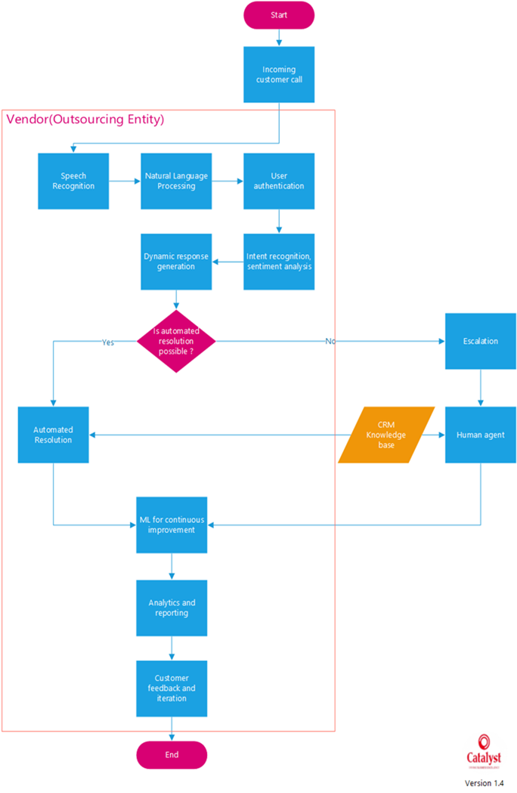

This solution entails contracting with a third-party vendor to develop, implement, and manage an AI customer support call platform. The supplier shall bear liability for (Trowbridge, n.d., para 1-8):

1. **AI Development & Integration:** Construct and integrate AI chatbots to answer standard questions and perform simple troubleshooting, trained on Rogers’s customer service data.

1. **Platform Management:** establishing and overseeing the infrastructure of the AI call platform, including regular updates and maintenance.

1. **Call Routing & Overflow Handling:** creating a system that would transfer calls from customers to the AI platform for simple questions and to Rogers' internal support agents for more complicated issues.

1. **Performance Monitoring & Reporting:** delivering frequent performance reports to Rogers on the platform, including data on call deflection rates, customer satisfaction ratings, and agent productivity.

### Impact Analysis

#### Impact on People

1. **New Skill Set:** More training might be required for Rogers' agents in order to work with the AI platform and manage escalated problems.

1. **Change in Jobs:** Depending on the volume of calls deflected by the AI, there might be a decrease in the number of calls handled by human agents, which could necessitate a change in job responsibilities or a reduction in workforce size. This eventually means that human agents have to either let go of them or learn new, pertinent skills.

1. **New Hires:** Rogers might have to bring on more employees with experience in analytics and AI management to supervise the contracted platform.

#### Impact on Process

1. **Call Routing and Triage:** The AI platform will add a new level of call routing and triage, which could simplify the procedure and shorten client wait times.

1. **Knowledge Management**: The AI platform will need strong knowledge management procedures to guarantee that the knowledge base is accurate and up to date, reflecting modifications to the policies, services, and products.

1. **Performance Monitoring:** It will be necessary to set up new procedures for tracking the AI platform's effectiveness, getting user input, and enhancing its features over time.

#### Impact on Technology

1. **Integration with Existing Systems:** The AI platform must be seamlessly integrated with the current call center infrastructure, billing systems, CRM systems, and other pertinent data sources of Rogers Telecommunication.

1. **Data Security and Privacy:** To secure customer data and guarantee compliance with pertinent regulations, strong data security and privacy measures must be put in place.

1. **Infrastructure and Scalability:** More infrastructure and processing power might be needed for the AI platform to manage the expected call volume and maintain scalability as demand increases.

### 

### Out of Scope

The following aspects are considered out of scope for this solution:

1. **In-house development of the AI Customer Service Call Platform:** This solution only concentrates on contracting with a third-party vendor to develop and implement the AI platform.

1. **Hardware procurement and setup:** Unless otherwise stated in the contract, the vendor will be in charge of providing the infrastructure and hardware needed for the AI platform.

1. **Integration with other business units or departments outside of customer service:** Future integrations with other business divisions will be handled separately, with the AI platform's primary focus being customer service operations.

### Risk and Mitigation

1. **Vendor Selection and Performance Risk:** Making the incorrect vendor choice or running into problems with the vendor's AI platform performance could cause delays, extra expenses, and a less than ideal customer experience.

**Mitigation:** Make sure to evaluate vendors thoroughly, obtaining references and documentation of successful implementations in comparable settings. Implement strong performance monitoring systems and service-level agreements (SLAs).

1. **Data Security and Privacy Risk:** If customer data handling and system integration are not handled appropriately, there may be security and privacy risks.

**Mitigation:** Adopt stringent measures for data security and privacy, such as encryption, access controls, and adherence to pertinent laws (such as PIPEDA). Perform penetration tests and security audits on a regular basis.

1. **Integration and Compatibility Risk:** There may be delays and operational disruptions due to difficulties integrating the AI platform with Rogers Telecommunication's current systems and infrastructure.

**Mitigation:** Make sure the vendor has expertise in integrating with comparable systems and carrying out extensive compatibility testing. Create backup plans and rollback techniques in case there are integration problems.

1. **User Adoption and Change Management Risk:** The AI platform may not be implemented as effectively or as profitably as it could if customers or customer service representatives are resistant to using it.

**Mitigation:** To address concerns and encourage user adoption, put in place thorough training programs for customer service representatives and create efficient communication and change management plans. Obtain input, then adjust as necessary.

1. **Vendor Lock-in Risk:** The AI platform's heavy reliance on one vendor may result in vendor lock-in, which makes it challenging to move providers or adjust to shifting market conditions.

**Mitigation:** Strike flexible terms in the vendor's contract to guarantee that systems and data can be moved if necessary. In the future, look into possibilities for open-source alternatives or multi-vendor support.

## POSSIBLE SOLUTION #2 – (Using Third-party AI products)

### High-Level Design

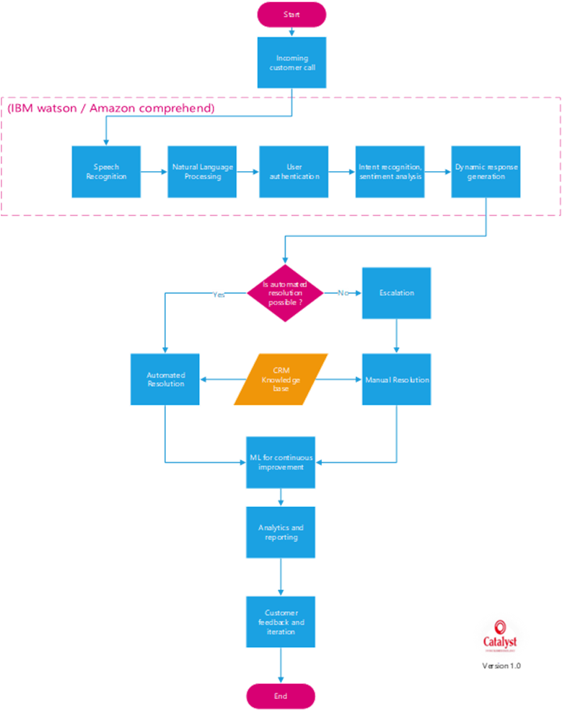

### Impact Analysis

1. **Better customer satisfaction:** Implementing an AI customer support system can greatly improve customer experiences by responding quickly and accurately. Customers benefit from instant support, which increases satisfaction and thereby loyalty.

2**. Increased efficiency in handling routine queries:** Routine queries can be automated, freeing up customer support personnel’s time to focus on resolving only more challenging complaints. This can also reduce the manpower required to efficiently run the operation.

3. **Time and Cost Savings**: The automated resolution ends up saving costs for customer support operations. The resources can also be scaled easily according to future needs with minimal overhead.

4. **Cost of implementation:** The upfront expenditures of deploying an AI customer service system, which include technology purchase, development, and training will involve sizeable investment.

### Out of Scope

1. **Not a complete replacement:** This AI technology is supposed to supplement and improve the existing customer service, rather than to completely replace it. Human empathy and complex problem-solving abilities are critical in certain situations.

2. **Does not have complete autonomy:** The AI system functions under supervision whenever needed and is not assumed to have complete autonomy. Human interaction will be required for key decisions and escalated complaints.

### Risk and Mitigation

1. **Inaccurate Responses:** The AI providing inaccurate or inappropriate responses is a very evident risk. This can be overcome by regularly updating the knowledge base, conducting extensive testing, and implementing user feedback mechanisms.

2. **Integration challenges:** Since this implementation is retrofitting the existing customer care system, parts of the new system must be well integrated with existing databases and systems. This could prove a potential risk. To mitigate the same, we must conduct thorough compatibility assessment tests and use standardized integration protocols.

3. **Legal and Compliance Issues:** Since the responses are dynamically generated, there is always a risk of not being compliant with regulatory policies. This can only be handled using a robust governance framework and adequate testing and training.

4. **Dependency on External Services:** A critical chunk of the process depends on the products of external services. This could risk being overdependent. Diversity of vendors, wherever possible, should be established, and comprehensive SLAs must be drafted to deal with the same.

## POSSIBLE SOLUTION #3: Do Nothing Method

### Impact Analysis

#### Impact on people

**Hiring Requirements:** If AI automation is not implemented, Rogers may need to hire more employees to handle the increasing workload. This could result in increased operating expenses and resource pressure.

#### Impact on Processes

**1. Inefficiencies and Service delays:** Customer service procedures may continue to be ineffective and error prone. Customer satisfaction might drop, and response times may increase when queries are handled manually.

**2. Scalability Problems:** When customer demands increase, manual processes may find it difficult to grow efficiently. This could result in backlogs, a lag in problem solving, and eventually, the loss of customers.

**3. Absence of Data Utilization:** AI-powered systems can collect and examine enormous volumes of client data, offering insightful information for forecasting customer demands and enhancing services. Rogers might lose out chances to improve client experiences and drive company growth in the absence of such technologies.

Impact on Technology  
   
**1. Lack of Innovation:** Not utilizing AI voice assistant technology means passing on chances to use advanced solutions to enhance customer support. This might cause the market to stagnate and give Rogers a competitive edge over rivals.

**2. Dependency on Outdated Systems:** Rogers may be forced to continue using antiquated systems, which are expensive to maintain and inefficient, if new technology is not adopted. This could hinder creativity and make it more difficult for the company to adjust to changing customer demands.

**3. Danger of Falling Behind**: Companies who do not adopt AI and automation run the risk of lagging behind their rivals in the quickly evolving technology world of today. In order to be competitive and draw in new business, Rogers can find it difficult to stay up to date with developments and trends in the market.

### Risks and Mitigation

#### Risks

**1. Increased Operational Costs:** In the absence of AI automation, Rogers may still place a significant emphasis on using human customer care agents to answer questions. The need for more employees to handle the same volume of requests could lead to higher operational expenditure.   
  
**2. Reduced Efficiency:** Responding to consumer inquiries manually can be laborious and error-prone, which reduces the speed at which problems are resolved and responses are given. Customers may become unhappy as a result, harming the business's reputation.   
  
**3. Limited Scalability:** As customer demands increase, manual customer support procedures could find it difficult to grow as efficiently. This may result in bottlenecks, extended wait times, and trouble managing periods of high client traffic.

**4. Missed Opportunities for Personalization:** AI voice assistants can analyze client data and offer responses or recommendations that are tailored to the individual. In the absence of this technology, Rogers would lose out on possibilities to customize their offerings to suit the unique preferences of each client, which would lower client satisfaction and loyalty.   
  
**5. Competitive disadvantage:** Customers expect quick and effective service in the digital age. In comparison to rivals that provide automated and simplified customer care solutions, Rogers may face a competitive disadvantage if it chooses not to deploy AI voice assistant customer service.

## 

#### Mitigations Strategies

**1. Continuous Process Improvement:** To cut down on inefficiencies and simplify manual customer service procedures, put continuous process improvement efforts into action. This could entail streamlining processes, cutting out pointless effort, and putting best practices for providing customer service into effect.   
  
**2. Investing in Training and Development:** To improve the skills and talents of customer service agents in efficiently managing consumer questions, offer them extensive training and development programs. This can lessen the impact of not having AI automation by giving staff members the tools they need to provide excellent customer support.   
  
**3. Improved Customer Self-Service choices:** To enable customers to independently find solutions to their questions, invest in self-service choices including online FAQs, chatbots, and self-service portals. This can enhance overall service efficiency and lessen the workload for human customer support staff.

**4. Emphasis on Customer Experience:** Prioritize providing outstanding customer experiences through tailored interactions and anticipatory correspondence. By encouraging client loyalty and satisfaction, this can help set Rogers apart from competitors and reduce the negative effects of not having an AI voice assistant for customer support.   
  
**5. Keep an Eye on Industry Trends:** Keep up with developments in the field of customer service automation and upcoming technologies. This can assist Rogers in finding fresh chances for innovation and sustaining its competitiveness in the quickly changing market.

# Evaluation Criteria

## People

1. **Performance:** Determine how well the AI platform performs by analyzing the percentage of accurately responding to customer inquiries to indicate how well it can comprehend and reply to queries.  
    Accuracy rate of correctly addressed inquiries:
   * <80% - Poor
   * 80% - 90% - Fair
   * 90% - 95% - Good
   * 95% - Excellent

1. **Proactive:** Evaluate the platform's capacity to anticipate typical problems and offer preventive solutions to assess how proactive it is in meeting customer needs.  
    Percentage of preventive solutions provided:
   * <30% - Low
   * 30% - 50% - Moderate
   * 50% - 70% - High
   * 70% - Very High

1. **Intuitive:** Assess the AI platform's user interface and interaction flow for intuitiveness, considering user input about the easy nature of menu navigation and feature access.  
    User satisfaction with UI and interaction flow:
   * <6/10 - Below Average
   * 6/10 - 7/10 - Average
   * 7/10 - 8/10 - Good
   * 8/10 - Excellent

1. **Responsive:** Measure how long the AI platform takes to start and finish customer interactions.  
    The average time taken to initiate and complete customer interactions:
   * 2 minutes - Slow
   * 1 - 2 minutes - Moderate
   * 30 seconds - 1 minute - Fast
   * <30 seconds - Very Fast

1. **Adaptability:** Assess how well the platform accommodates users with various technical and language proficiency levels and their preferences and communication styles.  
    User satisfaction with adaptability:
   * <70% - Low
   * 70% - 80% - Moderate
   * 80% - 90% - High
   * 90% - Very High
2. **Empathy:** Assess how well the platform communicates empathy and comprehension throughout customer interactions, offering comfort and emotional support as needed.  
    Customer satisfaction with empathy conveyed:
   * <70% - Low
   * 70% - 80% - Moderate
   * 80% - 90% - High
   * 90% - Very High

1. **UI/UX:** Analyze the platform's user interface (UI) and user experience (UX), the overall ease of use and satisfaction of users with this platform service, using metrics such as the average time required to complete a customer call, the percentage of users who can operate the system successfully without assistance, and the user satisfaction ratings from surveys or other channels.

## Process

1. **Productivity:** Determine how productive the platform is by counting the number of calls it handles in an hour. The higher the number, the more effective the platform. Number of calls handled per hour:

* <500 - Not productive
* 500 - 1000 - Little productive
* 1000 - 1500 - Productive
* 1500 - 2000 - Highly Productive
* 2000 - Max productivity

1. **Efficiency:** Evaluate how well the platform handles calls, considering variables like call duration, resolution time, and resource usage per call.

Average call duration:

* + 7 minutes - Lengthy
  + 5 - 7 minutes - Moderate
  + 2 - 5 minutes - Efficient
  + <2 minutes - Very efficient

1. **Automation:** Determine how much the call-handling process is automated by considering the percentage of regular questions handled without human participation.

Percentage of routine inquiries handled without human intervention:

* + <50% - Low
  + 50% - 70% - Moderate
  + 70% - 90% - High
  + 90% - Very High

1. **Flexibility:** Assess the platform's flexibility in various customer service situations and ability to handle various question types efficiently. Additionally, the process's flexibility to accommodate changes in it for future demands and changes will be assessed.

User satisfaction with the platform's ability to handle various query types:

* + <70% - Low
  + 70% - 80% - Moderate
  + 80% - 90% - High
  + 90% - Very High

1. **Scalability:** Evaluate the platform's capacity to grow by increasing call volumes and customer service demands. The platform's potential to handle more calls than standards without affecting performance will be checked.  
    Percentage increase in call volumes before performance degradation:

* <50% - Low scalability
* 50% - 100% - Moderate scalability
* 100% - 150% - High scalability
  + 150% - Very high scalability

1. **Reliability:** Evaluate the platform's reliability in providing consistently excellent customer service by considering variables, including error handling capabilities, call drop rates, and system uptime.  
    Uptime percentage:
   * <99% - Unreliable
   * 99% - 99.9% - Reliable
   * 99.9% - Highly reliable

1. **Incident Management:** Assess the incident management features of the platform, such as ticketing systems and escalation protocols, to guarantee prompt customer service and efficient resource utilization.  
    Average resolution time for critical issues:
   * 1 hour - Slow
   * 30 minutes - 1 hour - Moderate
   * 15 - 30 minutes - Fast
   * <15 minutes - Very Prompt

1. **Knowledge Management:** Evaluate the platform's knowledge management system to ensure that an extensive collection of FAQs, troubleshooting manuals, andproduct/service details is arranged and updated to assist with customer inquiries.  
    Accuracy rate of provided information:
   * <80% - Low
   * 80% - 90% - Moderate
   * 90% - 95% - High
   * 95% - Very high

1. **Quality Assurance:** Evaluate the platform's quality assurance procedures for monitoring call quality, conformity to service guidelines, and legal compliance to preserve service excellence.  
    Average quality score based on customer feedback and call monitoring:
   * <80% - Low
   * 80% - 90% - Moderate
   * 90% - 95% - High
   * 95% - Very high

1. **Compliance:** Check if the platform complies with industry standards and legal obligations, such as GDPR, to safeguard customer privacy and data security.

## Technology

1. **Security:** Assess the platform's adherence to industry standards and laws, including GDPR and HIPAA, and its security procedures for safeguarding sensitive data and client information.
2. **Availability:** Measure the platform's availability in terms of uptime; high availability(uptime) guarantees continuous customer support activities.  
    System uptime:
   * <99%: Low availability
   * 99%-99.9%: Moderate availability
   * >99.9%: High availability
3. **Data Specification:** Evaluate the platform's compliance with data standards and specifications to ensure it works with current data systems and protocols and is compatible.

Compliance with data standards:

* Non-compliant: Incompatible with existing systems
* Partially compliant: Some compatibility issues
* Fully compliant: Compatible with standards

1. **Encryption:** Examine the platform's encryption features, considering the robustness and efficiency of the used encryption methods, to ensure the security of data transmission and storage. Encryption steps and levels are considered.
2. **Backup Mechanisms:** Assess the platform's backup procedures for preserving and safeguarding important information and configurations. Regularity of call transcripts, user preferences, and system settings are backed up to avoid data loss in case faults or system failures are checked.

1. **Disaster Recovery Planning:** Evaluate the platform's disaster recovery plans and protocols to lessen the effects of unanticipated incidents or interruptions. How these plans are well detailed for different purposes such as continuity, system recovery, and data restoration to reduce downtime and preserve service availability are checked.
2. **Speech Recognition Accuracy:** Assess how well the voice recognition technology on the platform interprets and transcribes client requests, which can reduce miscommunication and mistakes during encounters. Accuracy rate in transcribing inquiries:
   * <90%: Inaccurate
   * 90%-95%: Moderate accuracy
   * >95%: High accuracy

1. **Natural Language Understanding:** Evaluate how well the platform can interpret difficult questions, slang, and colloquial language to respond to users with accurate and relevant information.  
    Ability to interpret complex queries:
   * <70%: Poor understanding
   * 70%-85%: Moderate understanding
   * >85%: High understanding

1. **API Accessibility:** Assess how easily application programming interfaces (APIs) on the platform can be customized and extended, facilitating seamless interaction with third-party tools and services like databases and CRMs.

# Database Design

The database design for Generative AI Powered Voice Assistant Customer Service at Rogers includes multiple tables that reflect various aspects of client interactions, inquiries, and system operations. The tables have been standardized to ensure data integrity and efficiency in retrieval and manipulation.

1. AgentCallAssignments: This table would map customer service agents to specific customer calls or interactions, enabling tracking and assignment of calls to available agents.
2. Agents: This table will store information about the customer service agents, such as their employee ID, names, and role.
3. ResolutionDetails: This table will store the details of when the customer's issue or ticket was resolved, including a description, solutions provided, and any relevant notes.
4. CallTranscripts: This table would store the transcripts of customer calls or voice interactions with the AI assistant, enabling analysis and training of the conversational AI models.
5. CallIntents: This table would store the various intents that the voice assistant needs to recognize and handle during customer calls.
6. CustomerInteractions: This table would log and store details of customer interactions with the voice assistant, such as interaction ID, Ticket ID, timestamp, and any relevant metadata.
7. TicketCategories: This table would store the different categories or types of customer service tickets or issues, enabling better routing and handling of tickets based on their category.
8. VoiceModels: This table would store the trained voice models, enabling the voice assistant to support multiple languages, accents, and customizable voice personas.
9. InteractionFeedback: This table would store customer feedback and ratings for their interactions with the voice assistant, enabling quality assurance and continuous improvement of the conversational AI models.
10. CallTags: This table would store tags or labels that can be associated with customer calls or interactions, enabling better categorization and analysis of call data.
11. SentimentDetails: This table would store sentiment analysis data extracted from customer interactions, such as sentiment scores, emotions detected, and other relevant metadata. This information can be used to adapt the voice assistant's responses and handle customer emotions more effectively.

## 

## Tables

**1. Customers**

|  |  |  |
| --- | --- | --- |
| Element Name | Value Range | Data Type |
| CustomerID (PK) | Positive integers (no duplicates) | INT |
| FirstName | Text strings | VARCHAR (50) |
| LastName | Text strings | VARCHAR (50) |
| Email | Unique email addresses | VARCHAR (255) |
| PhoneNum | Text strings with appropriate formatting (e.g., +1234567890) | VARCHAR (20) |
| Addr1 | Text strings | VARCHAR (255) |
| Addr2 | Text strings | VARCHAR (255) |
| City | Text strings | VARCHAR (100) |
| State | Text strings (consider using a standardized abbreviation list) | VARCHAR (50) |
| Zip | Text strings with appropriate formatting (e.g., 12345) | VARCHAR (10) |
| Country | Text strings | VARCHAR (100) |
| UserPref | Text strings or a coded system representing preferences | VARCHAR (100) |

**2. Tickets**

|  |  |  |
| --- | --- | --- |
| Element Name | Value Range | Data Type |
| TicketID (PK) | Positive integers (no duplicates) | INT |
| Title | Text strings | VARCHAR (255) |
| Description | Text strings | TEXT |
| Status | Defined list of status options | VARCHAR (10) |
| Priority | Defined list of priority options | VARCHAR (10) |
| CreatedAt | Date and time format (e.g., DATETIME) | DATETIME |
| UpdatedAt | Date and time format (e.g., DATETIME) | DATETIME |
| CustomerID | Positive integer referencing Customers.CustomerID | INT |
| ResolutionID | Positive integer referencing ResolutionDetails.ResolutionID (can be NULL if not resolved) | INT |
| TicketCategory | Defined list of category options | VARCHAR (100) |

**3.AgentCallAssignments**

|  |  |  |
| --- | --- | --- |
| Element Name | Value Range | Data Type |
| AssignmentID (PK) | Positive integers (no duplicates) | INT |
| TicketID | Positive integer referencing Tickets.TicketID | INT |
| AgentID (FK) | Positive integer referencing Agents.AgentID | INT |
| AssignedTime | Date and time format (e.g., DATETIME) | DATETIME |
| CompletionTime | Date and time format (e.g., DATETIME) | DATETIME |

**4. Agents**

|  |  |  |
| --- | --- | --- |
| Element Name | Value Range | Data Type |
| AgentID (PK) | Positive integers (no duplicates) | INT |
| EmployeeID | Text strings or integers referencing another system | INT |
| Department | Defined list of department options | VARCHAR (50) |
| RoleID | Positive integer referencing a Roles table (if applicable) | INT |

**5.ResolutionDetails**

|  |  |  |
| --- | --- | --- |
| Element Name | Value Range | Data Type |
| ResolutionId (PK) | A positive integer, auto-incrementing | INT |
| ResolutionDate | Date and time (YYYY-MM-DD HH:MM:SS) | DATETIME |
| ResolutionDesc | Textual description | VARCHAR (255) |
| ResolvedBy | Username or employee ID | VARCHAR (50) |
| Comments | Textual information | VARCHAR (255) |

**6.CallTranscripts**

|  |  |  |
| --- | --- | --- |
| Element Name | Value Range | Data Type |
| TranscriptId (PK) | A positive integer, auto-incrementing | INT |
| Transcript | Text data | TEXT |
| InteractionId (FK) | Positive integer referencing a valid InteractionId | INT |
| TimeStamp | Date and time (YYYY-MM-DD HH:MM:SS) | DATETIME |
| ConfidenceLevel | Decimal value between 0.0 and 1.0 (0 = low, 1 = high) | DECIMAL (3,2) |

**7.CallIntents**

|  |  |  |
| --- | --- | --- |
| Element Name | Value Range | Data Type |
| IntentId (PK) | A positive integer, auto-incrementing | INT |
| IntentName | Textual description (e.g., "check_balance", "report_outage") | VARCHAR (50) |
| IntentDesc | Textual explanation of the user's intent | VARCHAR (255) |
| ConfidenceLevel | Decimal value between 0.0 and 1.0 (0 = low, 1 = high) | DECIMAL (3,2) |

**8.CallTags**

|  |  |  |
| --- | --- | --- |
| Element Name | Value Range | Data Type |
| TagId (PK) | A positive integer, auto-incrementing | INT |
| TagName | Textual description (e.g., "urgent", "billing issue") | VARCHAR (50) |
| TagDesc | Textual explanation for applying the tag | VARCHAR (255) |

**9.CustomerInteractions**

|  |  |  |
| --- | --- | --- |
| Element Name | Value Range | Data Type |
| InteractionId (PK) | Positive integer, auto-incrementing | INT |
| TicketId (FK) | Positive integer referencing a valid TicketId or NULL if not linked to a ticket | INT |
| IntentId (FK) | Positive integer referencing a valid IntentId | INT |
| VoiceModelld (FK) | Positive integer referencing a valid VoiceModelld | INT |
| InteractionType | Textual description (limited set of options) | VARCHAR (20) |
| StartTime | Date and time (YYYY-MM-DD HH:MM:SS) | DATETIME |
| EndTime | Date and time (YYYY-MM-DD HH:MM:SS) | DATETIME |
| SentimentId (FK) | Positive integer referencing a valid SentimentAnalysisld | INT |
| Comments | Textual information | VARCHAR (255) |

**10 SentimentDetails**

|  |  |  |
| --- | --- | --- |
| Element Name | Value Range | Data Type |
| SentimentAnalysisId (PK) | Positive integers, no duplicates | INT |
| SentimentScore | Decimal values between -1.0 (very negative) and 1.0 (very positive), with 0 representing neutral | DECIMAL (5,2) |
| SentimentLabel | Predefined set of strings (e.g., "Positive", "Negative", "Neutral") | VARCHAR (255) |
| AnalysisTimestamp | Date and time values | DATETIME |

**11 TicketCategories**

|  |  |  |
| --- | --- | --- |
| Element Name | Value Range | Data Type |
| TicketCategoryId  (PK) | Positive integers, no duplicates | INT |
| CategoryName | Textual data | VARCHAR (255) |
| CategoryDesc | Textual data, potentially lengthy | TEXT |

**12 InteractionFeedback**

|  |  |  |
| --- | --- | --- |
| Element Name | Value Range | Data Type |
| FeedbackId (PK) | Positive integers, no duplicates | INT |
| InteractionId (FK) | Positive integers, no duplicates | INT |
| Rating | Integers between 1 (lowest) and 5 (highest) | INT |
| Comment | Textual data, maximum 4000 characters | TEXT |
| FeedbackDate | Date values | DATE |

**13 Voice Models Table**

|  |  |  |
| --- | --- | --- |
| Element Name | Value Range | Data Type |
| VoiceModelld (PK) | A positive integer, auto-incrementing | INT |
| VoiceModelName | User-defined name | VARCHAR (50) |
| Language | Defined set of language codes (e.g., "en-US", "fr-CA") | VARCHAR (10) |
| Gender | Defined set of options (e.g., "Male", "Female", "Neutral") | VARCHAR (10) |
| Description | Free text entry | VARCHAR (255) |
| Metadata | JSON format | TEXT |

## Primary Keys

|  |  |  |
| --- | --- | --- |
| **Table Name** | **Primary Key Name** | **Datatype** |
| Customers | CustomerID | Integer |
| Tickets | TicketID | Integer |
| AgentCallAssignments | AssignmentID | Integer |
| Agents | AgentID | Integer |
| Voicemodels | VoicemodelID | Integer |
| CallTranscripts | TranscriptID | Integer |
| CallIntents | IntentID | Integer |
| CustomerInteractions | InteractionID | Integer |
| TicketCategories | TicketCategoryID | Integer |
| CallTags | TagID | Integer |
| SentimentDetails | SentimentAnalysisID | Integer |
| InteractionFeedback | FeedbackID | Integer |
| ResolutionDetails | ResolutionID | Integer |

# 

## Dependencies of data elements

1. Each customer interaction is associated with exactly one voice model. However, a voice model may be associated with zero or one interaction.
2. A customer interaction can have either zero or one interaction feedback. Conversely, each interaction feedback is tied to exactly one customer interaction.
3. Every customer interaction contains exactly one sentiment detail, but a sentiment detail may be linked to multiple interactions or none.
4. Each customer interaction is linked to precisely one and only one ticket, while a ticket can be associated with multiple customer interactions or none.
5. Every customer interaction will have one and only one call intent, but a call intent may be connected to multiple customer interactions or none.
6. A customer interaction may have zero or multiple call tags, and vice versa.
7. Each customer interaction will have one and only one call transcript, and vice versa.
8. A customer can have many zero or many tickets and a ticket can be connected to one and only one customer.
9. A ticket can have zero or many agent call assignments while a agent call assignment will be connected to one and only one ticket.
10. A ticket will have one and only one resolution detail while one resolution detail can be connected to zero or many tickets.
11. A ticket can have one and only one ticket category and vice versa.
12. An agent call assignment can be connected to one and only one agent while an agent can have zero or many agent call assignment.

The design adheres to database normalization principles up to the first Normal Form to reduce repetition and dependencies. Primary and foreign keys are used to ensure referential integrity between connected tables.

Overall, this standardized database structure enables the effective store, retrieval, and interrelationship of customer data, issue details, interaction transcripts, and agent resources - all of which are critical needs for a voice AI assistant in customer support. The design serves as a solid basis for building the application logic and workflow on top of the database backbone.

# Solution Recommendation

The team evaluated three possible solutions against 26 criteria, including performance, proactiveness, intuitiveness, responsiveness, adaptability, empathy, UI/UX, productivity, efficiency, automation, flexibility, scalability, reliability, incident management, knowledge management, quality assurance, compliance, security, availability, data specification, encryption, backup mechanisms, disaster recovery, speech recognition accuracy, natural language understanding, and API accessibility.

Solution 1: Outsourcing the AI customer service call platform

Solution 2: Implementing a third-party AI product

Solution 3: Maintaining the "Do Nothing" method (current system)

After the evaluation, the team recommends implementing the third-party AI product (Solution 2) as the best option, with a total score of 228 compared to 218 for the outsourced AI platform (Solution 1) and 154 for the "Do Nothing" method (Solution 3).

The key advantages of the third-party AI solution include:

1. Enhanced customer experience through advanced AI capabilities

Rogers may create an extremely responsive and effective customer support contact platform by incorporating well-known AI tools like IBM Watson or Amazon Comprehend. Instant access to AI-powered support will benefit customers, reduce wait times, and enhance satisfaction.

1. Improved operational efficiency and productivity

Rogers may reduce the amount of work employees have to do by streamlining the customer support process through third-party AI tools. Human representatives may concentrate on resolving complicated issues that require human engagement, increasing productivity, and optimizing resources, while AI takes care of common questions and provides prompt responses.

1. Scalable and reliable infrastructure

Reliable and scalable solutions that can handle changes in customer service demands and call traffic variations are provided by well-established AI products. Rogers could rely on third-party AI platforms' robust infrastructure and redundancy mechanisms to guarantee high availability and continuous service delivery.

1. Comprehensive security, compliance, and data protection features

Third-party AI technologies offer customization possibilities, enabling the solution to be tailored to Rogers' unique needs and preferences. These platforms' versatility makes integrating them seamlessly with current workflows and systems possible, guaranteeing a smooth transition and no interruption to business as usual.

1. Customization and integration capabilities to meet Rogers' specific needs

Reputed companies create AI solutions with strict security and compliance requirements in mind. Rogers can maintain compliance with data privacy laws like GDPR and HIPAA while protecting sensitive client data from breaches or unauthorized access by using a reliable third-party AI platform.

1. Cost-effectiveness

Rogers can save money by not having to invest in as much in-house development and maintenance when using third-party AI tools. Rogers can maximize return on investment and optimize cost-effectiveness through scalable subscription plans and predictable pricing patterns.

The detailed evaluation matrix and ROI analysis further support the recommendation of the third-party AI solution as the most suitable and cost-effective option for Rogers.

# ROI Comparison of Customer Service Solutions

This report includes a detailed ROI comparison of the three solution options (Outsourced Platform, Third-Party Products, and Do Nothing) over a 5-year period.

The key elements of the ROI analysis are:

Cost Categories:

1. Implementation
2. Licensing
3. Maintenance
4. Operational
5. Enhancement
6. Training

|  |  |  |  |  |
| --- | --- | --- | --- | --- |
| Cost Category | Years | Solution 1 (Outsourced Platform) | Solution 2 (Third-Party Products) | Solution 3 (Do Nothing) |
| **Implementation** | 1 | $1,500,000 | $750,000 | $0 |
|  | 2-5 | $0 | $0 | $0 |
| **Licensing** | 1-5 | $500,000/year | $200,000/year | $0 |
| **Maintenance** | 1-5 | $300,000/year | $100,000/year | $0 |
| **Operational** | 1 | -$200,000 (reduced efficiency) | -$100,000 (reduced efficiency) | $0 |
|  | 2 | -$150,000 | -$75,000 | $150,000 (increased workload) |
|  | 3-5 | -$100,000 | -$50,000 | $200,000 (increased workload) |
| **Enhancement** | 1-5 | $100,000/year | $50,000/year | $50,000 |
| **Training** | 1 | $200,000 | $100,000 | $50,000 |
|  | 2-5 | $50,000/year | $25,000/year | $50,000/year |
| **Total Cost** | 1 | $2,600,000 | $1,200,000 | $100,000 |
|  | 2 | $950,000 | $375,000 | $250,000 |
|  | 3 | $950,000 | $375,000 | $300,000 |
|  | 4 | $950,000 | $375,000 | $300,000 |
|  | 5 | $950,000 | $375,000 | $300,000 |

Benefits (Assumed):

1. Increased Customer Satisfaction: +$500,000/year (Years 1-5)
2. Reduced Customer Churn: +$500,000/year (Years 1-5)
3. Increased Agent Efficiency: +$300,000/year (Years 2-5)
4. Operational benefit:

* Solution 1: $450,000 (Years 1-5)
* Solution 2: $225,000 (Years 1-5)
* Solution 3: None (accrues a loss)

Total ROI:

1. Solution 1 (Outsourced Platform): 32.03%
2. Solution 2 (Third-Party Products): 171.30% (Highest ROI)
3. Solution 3 (Do Nothing): Cannot be calculated (No Investment)

The ROI analysis demonstrates that the third-party AI product (Solution 2) offers the highest return on investment over the 5-year period, making it the most cost-effective option.

Rogers' current initiative to enhance the customer service call system could be effectively achieved by integrating third-party AI solutions into the customer service call platform, making it the optimal choice.

# Implementation Strategy

The implementation of the AI customer service platform will follow a phased approach to minimize disruption and ensure a smooth transition:

Phased Migration Plan:

1. Pilot Phase: Select a subset of customer service calls by geography to use the AI-powered system for handling complaints. Gather feedback from representatives and customers to fine-tune the AI model and interface.
2. Departmental Rollout: Roll out the AI system to specific departments or call centres, gradually expanding its usage across different regions or teams. Provide targeted training sessions and support to these departments.
3. Full Deployment: Implement the AI system across all customer service channels and locations. Monitor system performance closely and provide ongoing support to address any issues or concerns.

The phased approach allows for incremental testing, feedback collection, and modifications, lessening the impact of possible issues on the entire system at once.

Other key components of the implementation strategy include:

1. Early Life Support: Offer dedicated support during the initial period after deployment to address any operational issues or user concerns.
2. Release Closure: Document actions, update configuration management records, and validate completion criteria to officially close each release phase.
3. Client Engagement and Training: Engage the customer throughout the implementation process and provide extensive training sessions for end users, administrators, and support staff.
4. Backout Strategy: Develop a detailed backout plan outlining the steps and procedures for reverting to the previous system or configuration.
5. Continuous Improvement: Establish a process for continuous improvement to address evolving customer needs and optimize the AI system's performance over time.

Continuous Improvement: Post-deployment, a process for continuous improvement will be established to address evolving customer needs and optimize the AI system's performance over time.

Regular reviews and updates will be conducted based on customer and staff feedback, ensuring the system remains effective and aligned with Rogers' objectives.

Cost and Resource Allocation: Detailed cost estimation and resource allocation plans will be provided to the client based on the chosen deployment approach and training strategy. The client will be informed about the manpower required from their side for successful implementation, including participation in training sessions, providing feedback, and ongoing support.

By following this phased approach to implementation, engaging the client throughout the process, and providing comprehensive training and support, we aim to minimize risks and ensure a successful deployment of Roger's AI customer service system.

# Testing Strategy

The testing strategy for the AI customer service platform follows an iterative, Agile approach, with testing activities integrated into each sprint. The key testing types include:

1. Unit Testing: Validate the functionality of individual AI modules, such as natural language processing and speech recognition.

1.1 Entry Criteria

* Completion of code development for individual AI modules (e.g., NLP, speech recognition).
* Availability of unit test cases covering all critical and high-priority functionalities.

1.2 Exit Criteria

* Successful execution of unit test cases with no critical defects related to the specific AI module.
* Code coverage of at least 80% for the unit-tested functionalities.

1. Integration Testing: Verify the integration of AI modules with other system components and external APIs.

2.1 Entry Criteria

* Completion of unit testing for individual AI modules.
* Availability of integration test environment with integrated AI modules and external APIs.

2.2 Exit Criteria

* Successful integration of AI modules with minimal defects affecting system functionality.
* Integration test coverage of at least 70% for the integrated components.

1. User Acceptance Testing (UAT): Validate the system's usability and effectiveness in real-world scenarios, ensuring alignment with user requirements.

3.1 Entry Criteria

* Completion of system testing and readiness for client validation.
* Availability of UAT environment resembling the production environment.

3.2 Exit Criteria

* Acceptance of the system by stakeholders with minimal critical defects affecting the usability.
* Successful completion of user acceptance test cases covering all defined acceptance criteria.

1. Performance Testing: Evaluate the system's response time, throughput, and resource utilization under different loads.

4.1 Entry Criteria

* Completion of system integration testing and readiness of the voice assistant system for performance testing.
* Availability of performance testing environment resembling the production environment.

4.2 Exit Criteria

* Response time for processing user queries meets predefined performance objectives under normal and peak load conditions.
* Stability of the voice assistant system is verified through prolonged load testing without significant performance degradation or system failures.

1. Security Testing: Identify vulnerabilities and ensure the system's resistance to unauthorized access, data breaches, and privacy violations.

5.1 Entry Criteria

* Completion of system integration testing and readiness of the voice assistant system for security testing.
* Availability of security testing environment with tools and configurations necessary for security assessments.

5.2 Exit Criteria

* No critical security vulnerabilities (e.g., authentication bypass, injection flaws, sensitive data exposure) are present in the voice assistant system.
* Compliance with security standards and best practices (e.g., OWASP Top 10, GDPR) is validated, ensuring the confidentiality, integrity, and availability of user data.

The testing approach includes comprehensive planning, daily stand-ups, incremental testing, review sessions, and user acceptance testing. Defect management protocols are established to track, triage, and resolve issues efficiently.

## Defect Flow

## Test Environment

* The development environment will include the necessary tools, IDEs, and version control systems for unit testing of the AI modules. Test data will be stored in version control repositories, and a backup and restore strategy will be implemented.
* The integration environment will simulate the voice assistant system components, integrated AI models, and external APIs for integration testing. Test data will be regularly backed up with a rollback strategy in place.
* The user acceptance testing (UAT) environment will resemble the production environment to provide a realistic testing experience for end-users, with test data backup and restore strategies aligned with the production environment.

## Testing Tools

* Test Management Tool (Jira): Jira will be used for managing test cases, tracking defects, and overall project management.
* Automation Tool (Custom Automation Frameworks): Custom automation frameworks will be developed specifically for testing the AI models and backend APIs of the voice assistant system. These frameworks will interact with the system's APIs and perform automated testing to validate the accuracy and functionality of the AI responses.
* Security Testing Tool (OWASP ZAP): OWASP ZAP will be used to perform security testing on the backend APIs and server-side components of the voice assistant system. It can help identify vulnerabilities such as injection flaws, authentication issues, and sensitive data exposure.
* Performance and Load Testing Tool (Apache JMeter): Apache JMeter will be utilized to conduct performance and load testing on the backend infrastructure of the voice assistant system. It can simulate concurrent requests and measure the system's response time, throughput, and scalability under different load conditions.

## Test Sign off:

* Test sign-off will be conducted at the end of each testing phase (e.g., sprint, release) by the test team lead or QA manager.
* Test sign-off may require verification of exit criteria such as:
  + Completion of test case execution
  + Resolution of critical defects
  + Achievement of test coverage goals

# Risk Management

The report identifies and addresses potential risks associated with the implementation of the AI customer service platform, including:

1. Risks for Outsourcing the AI Customer Service Call Platform:

|  |  |  |  |  |  |
| --- | --- | --- | --- | --- | --- |
| **ID. No:** | **Risk Description** | **Root Cause** | **Probability** | **Impact** | **Mitigation** |
| 1 | Data security breach | Insufficient security measures implemented | Medium | High - Loss of customer trust, legal repercussions | Implement robust encryption protocols, conduct regular security audits, and adhere strictly to data protection regulations |
| 2 | Vendor fails to deliver on AI platform | Lack of expertise or resources on the vendor's part | Medium | High - Delay in project timeline, loss of investment | Thoroughly vet vendors, request references and past performance data, include penalties for missed deadlines in the contract |
| 3 | Integration challenges with existing systems | Incompatibility between the AI platform and current infrastructure | High | High - Disruption to operations, increased costs | Conduct comprehensive compatibility testing before implementation, engage experienced integration specialists, and have a rollback plan in place |
| 4 | Low User Adoption | Resistance from employees or customers to the AI platform | Medium | High - Reduced effectiveness of solution, wasted investment | Provide comprehensive training and support to employees and customers, actively address concerns and feedback, highlight benefits of the AI platform |
| 5 | Dependency on third-party services | Reliance on external vendors for critical components | High | High - Vulnerability to vendor changes or disruptions | Diversify vendors where possible, establish strong SLAs and contingency plans, explore alternatives for critical services |

1. Risks for Third-party AI Products:

|  |  |  |  |  |  |
| --- | --- | --- | --- | --- | --- |
| **ID.NO:** | **Risk Description** | **Root Cause** | **Probability** | **Impact** | **Mitigation** |
| 1 | Inaccurate or inappropriate responses from AI | Insufficient training data or outdated knowledge base | Medium | High - Loss of customer trust, increased workload for human agents | Regularly update and refine training data, implement feedback mechanisms for continuous improvement, involve subject matter experts in AI model training |
| 2 | Legal and compliance issues | Failure to adhere to regulatory requirements | Medium | High - Legal penalties, reputational damage | Stay informed about relevant regulations, involve legal experts in the design and implementation process, conduct regular compliance audits |
| 3 | Dependency on third-party services | Reliance on external vendors for critical components | High | High - Vulnerability to vendor changes or disruptions | Diversify vendors where possible, establish strong SLAs and contingency plans, explore alternatives for critical services |
| 4 | Integration challenges with existing systems | Incompatibility between the AI platform and current infrastructure | High | High - Disruption to operations, increased costs | Conduct comprehensive compatibility testing before implementation, engage experienced integration specialists, and have a rollback plan in place |
| 5 | Low User Adoption | Resistance from employees or customers to the AI platform | Medium | High - Reduced effectiveness of solution, wasted investment | Provide comprehensive training and support to employees and customers, actively address concerns and feedback, highlight benefits of the AI platform |

R

1. Risks for the "Do Nothing" Method:

|  |  |  |  |  |  |
| --- | --- | --- | --- | --- | --- |
| **ID. No:** | **Risk Description** | **Root Cause** | **Probability** | **Impact** | **Mitigation** |
| 1 | Increased operational costs | Need for more employees to handle the workload | Medium | High - Increased expenses, resource pressure | Implement continuous process improvement efforts, invest in training and development for existing staff, explore self-service options for customers |
| 2 | Reduced efficiency | Manual handling of customer inquiries | Medium | High - Slow response times, decreased customer satisfaction | Streamline processes, invest in employee training, explore automation options for routine queries |
| 3 | Limited Scalability | Difficulty in handling increasing call volumes | High | High - Backlogs, extended wait times | Invest in scalable infrastructure, implement flexible service options, continuously monitor, and adjust resource allocation based on demand |
| 4 | Missed opportunities for personalization | Inability to analyze and utilize customer data | Medium | High - Decreased customer satisfaction, missed revenue opportunities | Explore options for data analysis and personalization, invest in customer relationship management tools, conduct regular customer feedback surveys |
| 5 | Competitive disadvantage | Inability to keep up with industry trends | Medium | High - Loss of market share, decreased competitiveness | Stay informed about industry developments, invest in innovation and technology adoption, and prioritize customer experience and satisfaction |

The risk management plan includes detailed risk logs for each solution option, addressing the specific risks and mitigation measures. This comprehensive approach to risk management aims to ensure the successful implementation and long-term viability of the AI customer service platform.

# References

[Submitted files - OneDrive (mcas.ms)](https://stuconestogacon-my.sharepoint.com.mcas.ms/personal/gkalaraveendran9759_conestogac_on_ca/_layouts/15/onedrive.aspx?ct=1706396587567&or=OWA%2DNT&cid=0021bb47%2D7cfd%2Dfc00%2D5153%2Dbe17e615411f&fromShare=true&ga=1&WSL=1&id=%2Fpersonal%2Fgkalaraveendran9759%5Fconestogac%5Fon%5Fca%2FDocuments%2FCapstone%20Project%20Group%205%2FSubmitted%20files)